# Application Build and Deployment steps

## Prerequisites:

1. Laptop/Desktop with java 8+ , Git and maven installed
2. Latest version of IDEs like STS or Eclipse
3. Project Setup

### Steps to build a jar:

* Open the IDE (STS or Eclipse) , Right click on the project and select

Run As -> Maven build

* Edit configuration pop up will appear, in the Goals text box type “***package***” and Click on Run

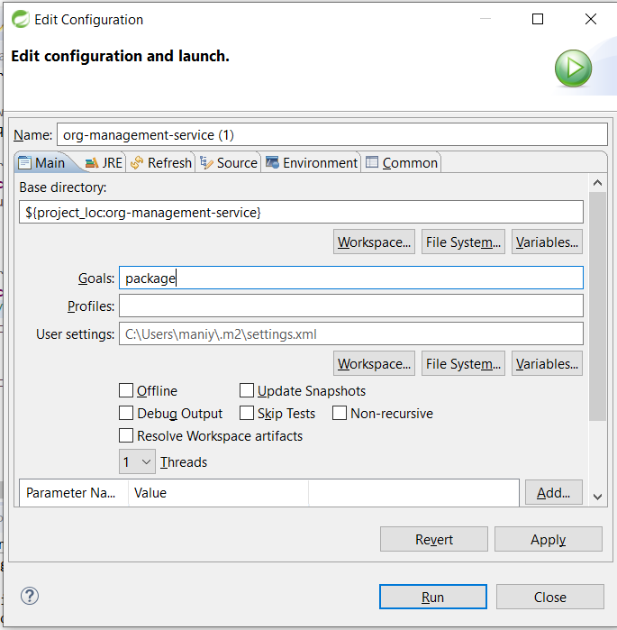

* Build will be started and we can see the progress of our build in the console.
* Once the build is completed the Jar will be placed at the target folder inside our project. The file path will be shown in the console as below. Copy the complete path including the jar name.

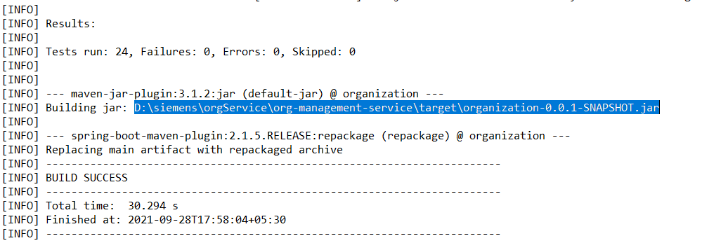

### Steps to Deploy the Application:

* Now create a text document inside your project and add the below line in your document.

Java –jar D:\siemens\orgService\org-management-service\target\organization-0.0.1-SNAPSHOT.jar

* Replace “D:\siemens\orgService\org-management-service\target\organization-0.0.1-SNAPSHOT.jar” with the complete path of your jar (which we have copied in pervious step) and save the file as app.cmd
* Now double click on the file, It’ll open a command prompt and the application will start running in background. To stop the application, just close the command prompt.